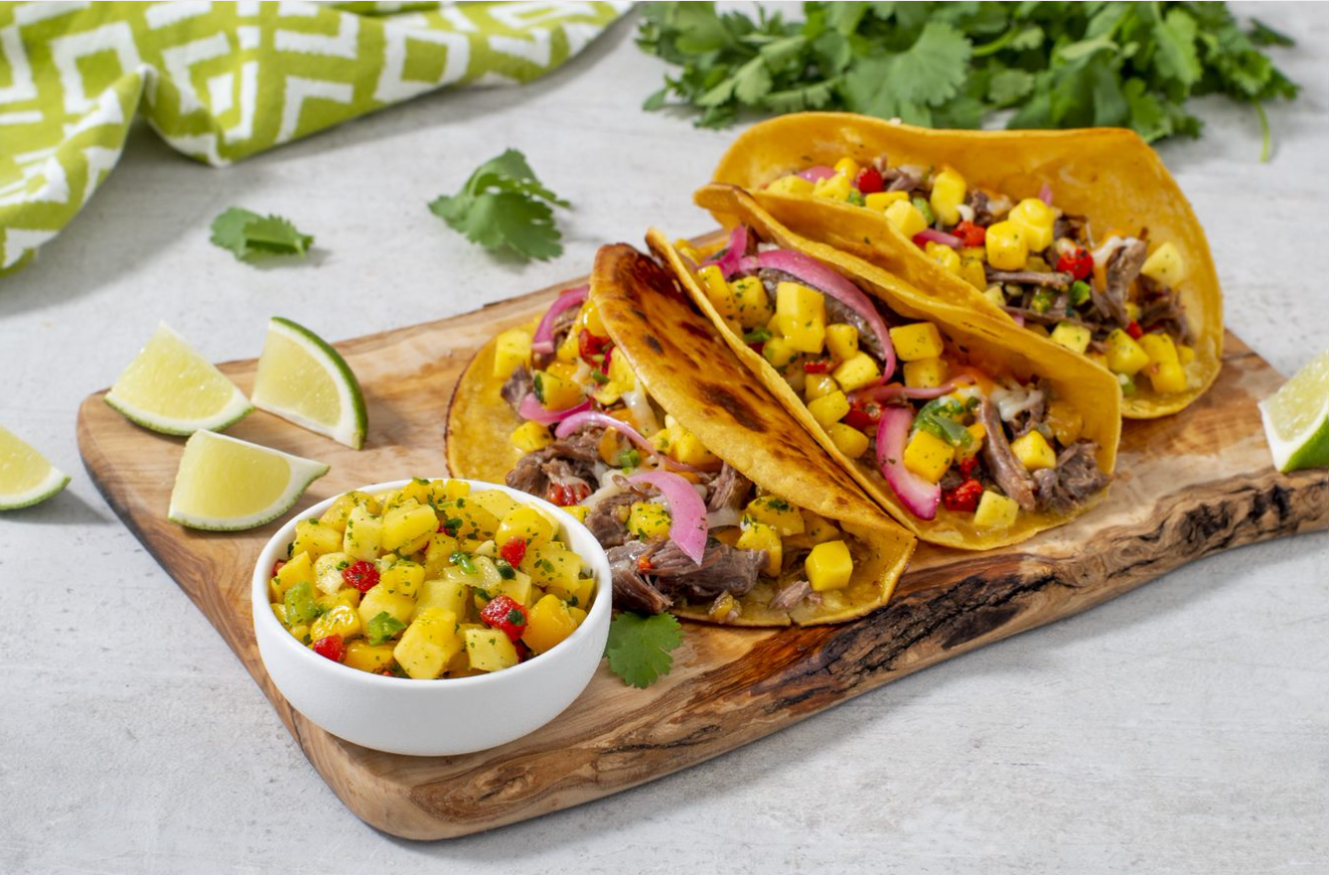
Mango Birria Tacos
Yield: 6 servings
Ingredients | Measurements | Nutrition Facts  (Per Serving)
Beef chuck pot roast, cut into 4-inch chunks | 3 lbs | Calories #  Fat #  Cholesterol #  Sodium #  Carbohydrate #  Fiber #  Sugars #  Protein #
Salt | 1 tsp
Black pepper | 1 tsp
SupHerb Farms® Mango Salsa Blend, divided | 2 1/2 cups
Beef broth | 2 cups
Ground cinnamon | 1/2 tsp
Shredded Tex-Mex cheese blend | 4 1/2 cups
Corn tortillas (5 inches), warmed | 18
 |  | Dietary Statements

PREPARATION
- Season beef with salt and pepper and transfer to slow cooker. Add 1 cup SupHerb Farms® Mango Salsa Blend, broth and cinnamon; stir to coat. Cover and cook on LOW for 6 to 8 hours (or on HIGH for 3 to 4 hours), until meat is very tender.
- Transfer beef to cutting board; using 2 forks, shred beef.
- Divide shredded beef and cheese among tortillas. Fold tortillas in half to enclose filling.
- Brush 1 tbsp of drippings from birria liquid in large skillet set over medium-high heat. In batches to avoid crowding, cook tacos, turning once, for 2 to 4 minutes or until tortillas are lightly golden and cheese has melted, adding more drippings as needed to the skillet.
TO SERVE
Arrange 3 tacos with 1/4 cup hot broth and 1/4 cup SupHerb Farms® Mango Salsa Blend for each serving.

TIP
Garnish with pickled red onion, cilantro and avocado slices if desired.

